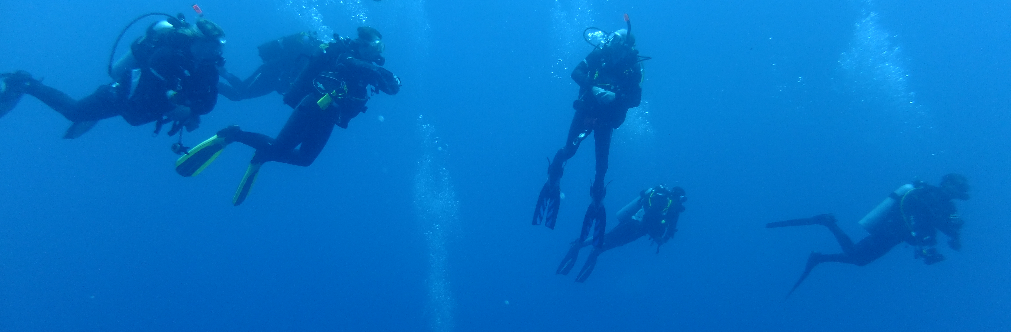
Equipment Rental Form
All fields highlighted with * must be completed prior to submission
Please complete 1 form per person
Personal Details
This person will be referred to as the ‘rentee’ in the Terms & Conditions.
Full Name*
Gender* |  |  | Date of Birth*
Address*
Post Code*
Phone No.*
Email Address
Date Equipment Required From*
Please indicate collection date.
Date Equipment Returned (due)*
Dive Society Member?
Dive Society Membership Level?
If ‘Yes’ to previous. Possible levels are: Gold, Silver or Bronze.
Dive Society Membership Current?
Highest PADI Qualification*
Please contact us if you are not a PADI certified diver but hold a qualification from another agency (e.g. BSAC).
Number of Dives* |  |  | Date of Last Dive*
Under Training?
Course Details
If ‘Yes’ to previous

Equipment Requirements
- Please indicate if required (X). We will assume the item is not required if a field is left blank.
- Unavailable sizes are indicated (-)
- Please contact us for sizing advice prior to booking, to arrange time to try on our equipment or if the required size is not shown.
- Evidence of experience will be required when renting a drysuit and/or requesting NITROX.
Sized Items
 | Junior | Extra Small | Small | Medium | Large | X Large | XX Large | XXX Large | ID #
Drysuit | -
Undersuit | -
BCD
Hood | - |  |  |  |  |  | - | -
Gloves | - |  |  |  |  |  | - | -
Wetsuit

All Other Items
 | Required | ID #
Open Water Fins (Please indicate UK shoe size)
Pool Fins (Please indicate UK shoe size)
Ankle Weights
Weights (Please indicate Kg required)
Regulator System (Open Water: includes gauges)
Mask & Snorkel
Dive Computer (Only available with regulator systems)
Dive Torch
SMB & Reel
Cylinder (10L or 12L. Please indicate if Nitrox is required & blend)
Drysuit Experience information
Please provide details of experience or the Diver No printed on the back of your PADI Drysuit Specialty certification card or your full name and date of birth in the space below. If you are not PADI certified, please provide a scanned copy of your equivalent certification no later than 3 working days prior to collection.
Nitrox Certification
Please provide the Diver No printed on the back of your PADI NITROX certification card or your full name and date of birth in the space below. If you are not PADI certified, please provide a scanned copy of your certification no later than 3 working days prior to collection.
Terms & Conditions
- This agreement is entered into between New Horizons Dive Centre Ltd and the Rentee (named previously), for the rental of scuba and/or skin diving equipment.
- Payment in full, including any appropriate discount, will be required on collection of the equipment. The total amount owing, including any discount, will be confirmed on request prior to collection.
- Photographic ID (e.g. driving licence or passport) and proof of address (e.g. utility bill dated within the last 3 months) must be presented on collection of the equipment by any Rentee that is not a current New Horizons Dive Society member.
- The Rentee hereby acknowledges receipt of the equipment designated in this form, and, if any of this equipment is to be used for scuba diving, that the Rentee is a certified scuba diver or student diver in a scuba diving course/program under the supervision of a certified scuba instructor.
- The Rentee acknowledges that the equipment is in good working condition and the Rentee has examined the equipment to ensure that it is free from defects, including checking both the quality and quantity of Air (or Nitrox) in any scuba tank(s) rented.
- The Rentee agrees to reimburse New Horizons Dive Centre Ltd any costs that may be incurred as a result of the return of Rental Equipment after the agreed return date, charged at the daily rate per item per day.
- The Rentee agrees to reimburse New Horizons Dive Centre Ltd for the loss or breakage of any and all equipment at the current replacement value and also pay for any damages incurred while transporting the equipment.
- The Rentee agrees to return the equipment in clean condition and to pay a cleaning fee if not returned cleaned.
- This agreement is a release of the Rentee's rights to sue for injuries or death resulting from the rental and/or use of this equipment. The Rentee expressly assumes all risks of skin and/or scuba diving related in any way to the rental and/or use of this equipment.
- The Rentee also understands that New Horizons Dive Centre Ltd and its employees, owners, officers or agents (hereinafter "Released Parties"), shall not be held liable or responsible in any way for any injury, death or other damages to the Rentee or his/her family, heirs, or assigns which may occur as a result of the rental and/or use of the equipment, or as a result of product defect, or any matter or condition under the control of the Rentee.
I, the Rentee, confirm that I have carefully read and understand the above agreement. By completing the following fields, I exempt and release New Horizons Dive Centre Ltd and all its related entities as defined above, from all liability or responsibility whatsoever for personal injury, property damage or wrongful death as a result of renting and/or using the equipment, however caused, including, but not limited to, product liability or any matter or condition under my control.*
Name*
Entering your name here will serve as your signature and will be viewed in the same manner.
Name of Parent or Guardian
If the rentee is under 18, please provide the name of a parent or guardian.
Date*
Please submit this completed form as an email attachment using the subject header:
Equipment Rental: Request

Please contact us if you haven't heard from us within 3 working days.
Email: | info@new-horizon.co.uk
Phone No.: | (01625) 611 108

